Behaviour 4 Tutorial

This tutorial will show you how to create a score and high score system.

**Step 1: Create a Canvas, inside create 2 text and one score and the other high score. In the inspector, change the text, text size, font or colour and place them where you think its best.**

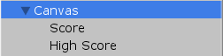



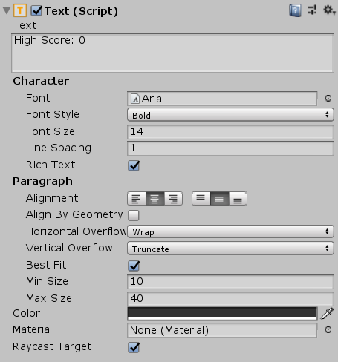

**Step 2: Create a script called Score and add it to the canvas. Open the script you just created.**

**Step 3:**

**We will need 4 variables.**

public int playerScore;  
  
    public float highScore;  
  
    public Text scoreTXT;  
  
    public Text highScoreTXT;

**Step 4:**

In Void start, we will set the high score.

    void Start () {  
        highScore = PlayerPrefs.GetInt ("HighScore", 0);  
   }

This looks for a player preference called HighScore and set our variable highscore equal to the integer save in HighScore. If there is no integer saved in HighScore then it will default to 0.

**Step 5:**

**In void Update, we will set our text variable scoreTXT and highScoreTXT. We will also compare the current score to our high score, if our current score is higher than high score we will save out score to our player prefs.**

void Update () {  
  
        scoreTXT.text = "Score: " + playerScore;  
  
        highScoreTXT.text = "High Score: " + highScore;

if (playerScore > highScore) {  
            PlayerPrefs.SetInt ("HighScore", playerScore);  
        }

    }

**This will update the text in our text variable.**

**Step 5**

Save the script and go back to the inspector in your canvas. Click and drag your score text to scoreTXT and high score text to highScoreTXT.

